CURRICULUM VITAE

Personal data:  Name and surname: Jarosław Sochacki  Address: Ul. Derkaczy 68  04-963 Warszawa  mobile phone: 0048 693 017 086  e-mail: j.p.sochacki@gmail.com | 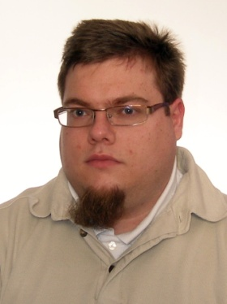

Education | 10/2008 – ongoing  Warsaw University  Institute of Applied Linguistics  Bachelor’s degree in Linguistics  (leading languages: Spanish/English)  10/2005 – 02/2008  Warsaw School of Economics.  Bachelor’s degree in Economy.  Studies interrupted for personal reasons.  09/2002 - 06/2005  XXXV L.O. z oddzialami dwujęzycznymi im. Bolesława Prusa w Warszawie.  High school, Computer Science focused.  Bilingual class with enhanced math and computer science.
Professional experience | 03/2006 - 08/2006 Intern  (with specialization in: international secretariat)  AHK (Polsko-Niemiecka Izba Przemysłowo Handlowa)  - Inputting contact information into an Access database. Completing sets of documents for mailing. Handling the document archive.  Translations  G-Tech sp. z.o.o.  - translating documents from English into Polish and from Polish into English (including technical texts)  As a freelancer, contracted on commission (profiles on www.proz.com. www. globtra.com www, trabajofreelance.es www.mojekorki.pl)
Foreign languages known | - Polish mother tongue  - Spanish excellent oral and writing knowledge  - German basic oral and writing knowledge  - Russian basic oral and writing knowledge
Skills | - Driver’s license  - Office equipment handling (computers, routers, modems, fax, xero...)  - Knowledge of Microsoft Office programs (Word, Excel, PowerPoint, Access)  - Experience with CAT (Computer Aided Translation) programs (Trados, Passolo, memoQ)
Interests | - Contrastive linguistics, tennis, safety in the internet, science fiction literature, TV series.

Jarosław Sochacki

